Laura Richardson Unit 3 Lab and Challenge:
- Maya ASCII (.ma) File
  - Your updated scene—same file with cleanup + new prop—committed to GitHub
    - 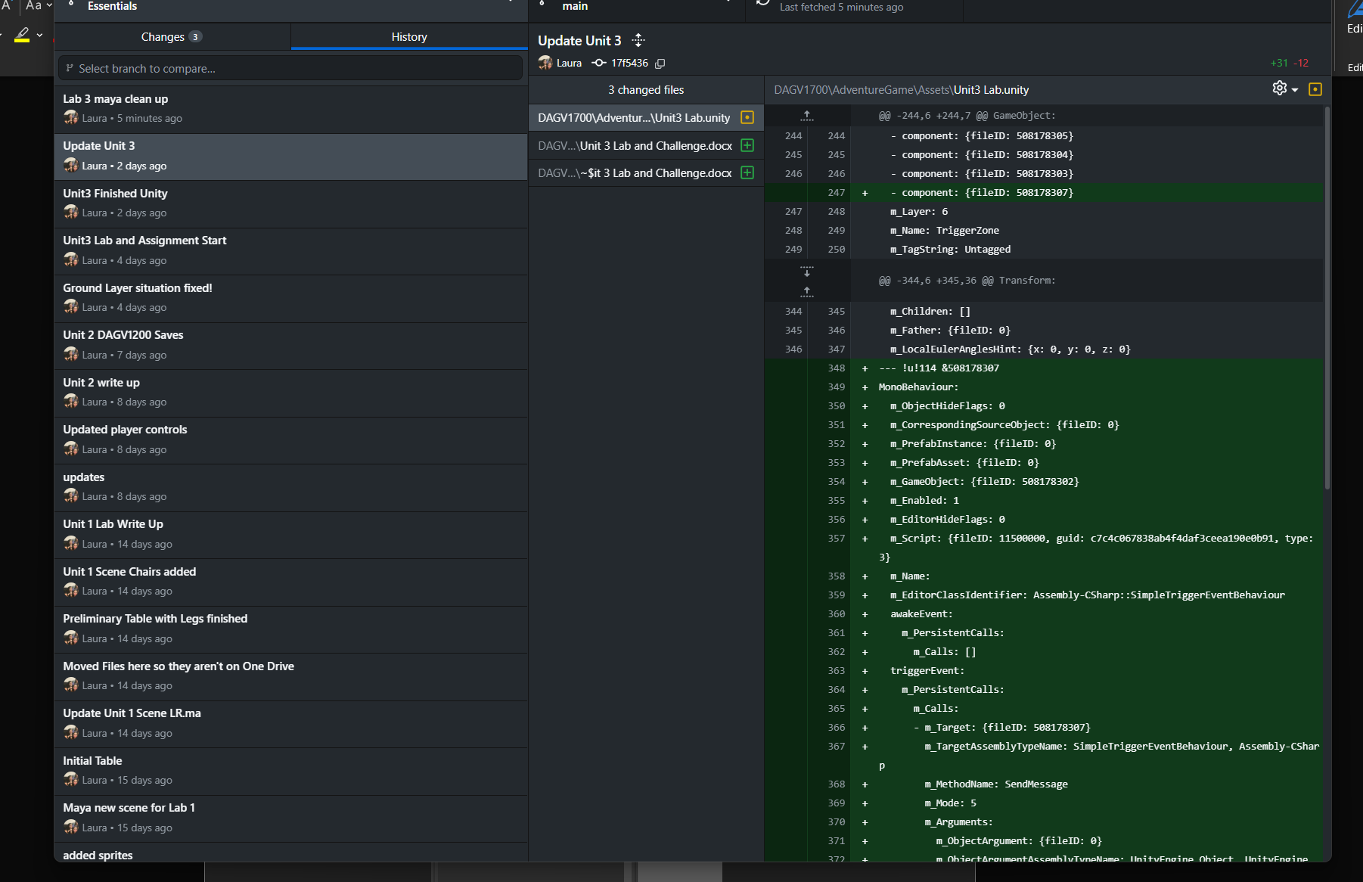
- PDF Package (single document) containing:
  - Screenshot #1: Outliner showing your renamed objects
    - 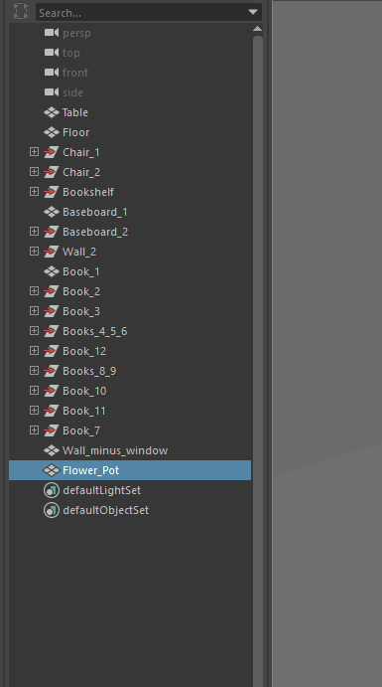
  - Screenshot #2: Viewport of one cleaned object with normals/edge flow visible
    - 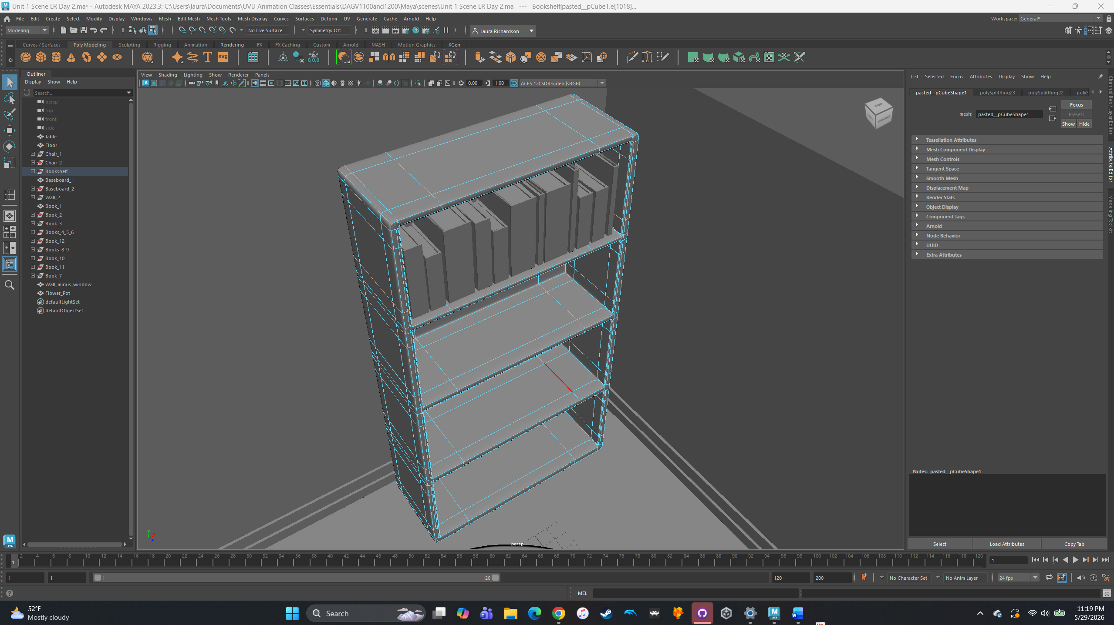
    - Cleaned up Bookshelf. There were a lot of n-gons because of the bevels. Also added edge loops to keep the corners crisp when viewing.
  - Screenshot #3: Viewport of your new prop in the room
    - 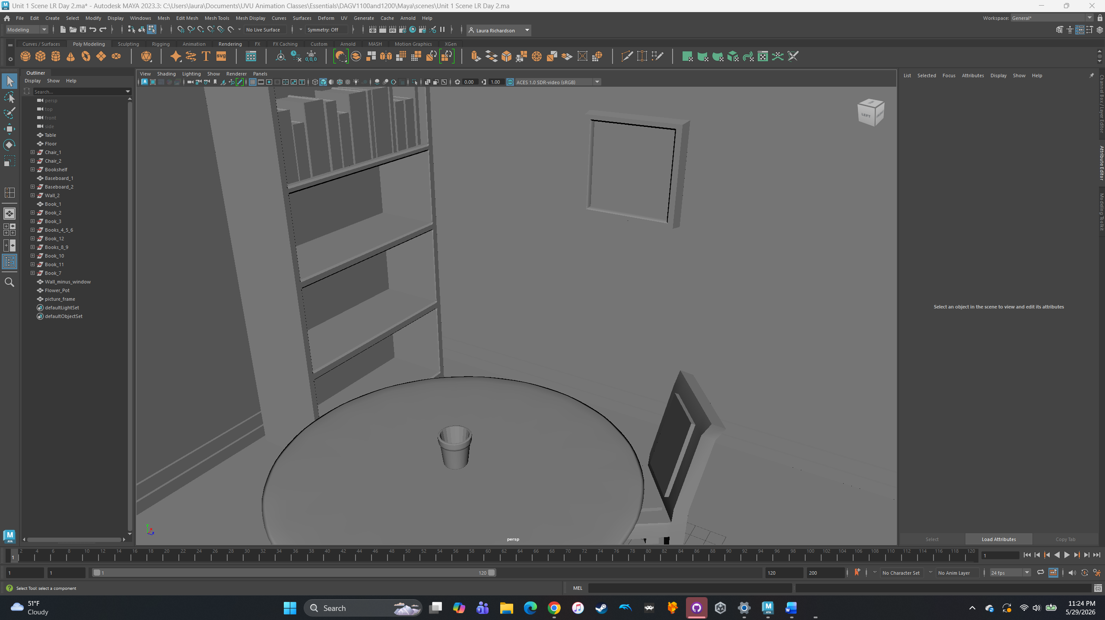
    - Added a picture frame and a flower pot.
  - 100-word reflection: Describe which cleanup step helped most and why you chose your new prop
    - The clean up step that helped me the most was the multi-cut tool. That bookshelf had so many n-gons, that I got familiar with the multi-cut tool. I love the insert edge loop tool as well and have used that a couple times in the past couple weeks. I added two new objects to my scene: a flowerpot and a picture frame. The table was looking bare, and I thought a flower would help, as well as that wall. I used the smooth visual graphics to see what the end product will look like once we render things.
- GitHub URL
  - https://github.com/richar65/Essentials
  - DAGV1100and1200/Maya/scenes/Unit 1 Scene LR Day 2.ma

